Week 1
Q1. Open a new document and type the following letter (in manual).
- Save the document as “Letter.doc.”
- Send the document to 3 recipients using Mail merge. (Use 3 different addresses)
- Define a Macro “Decorate” which makes the text bold, Red in color and italic, font size Assign a shortcut key Alt + Z to this macro.
- Close the document.
- The Sample Addresses are:
- Mr. Amit Tandon, 13, New Estate, Ring Road, Chandigarh
- Mr. Rohit Saluja, 15, Karol Bagh, New Delhi
- Ms. Jyoti Parmar, Sector 16, New Building, Gurugram
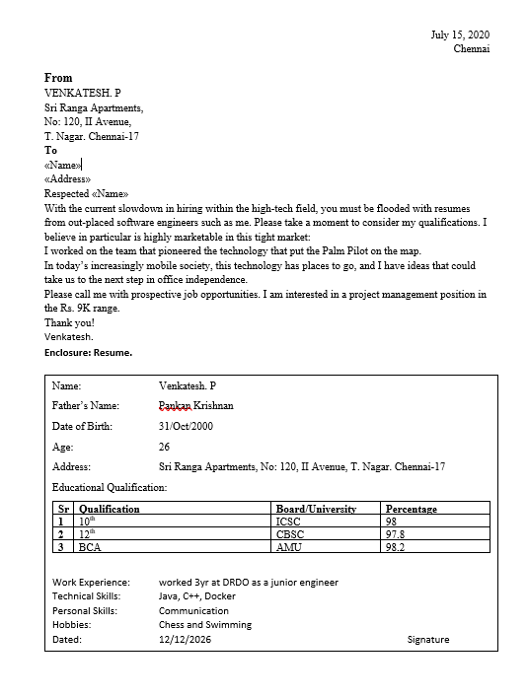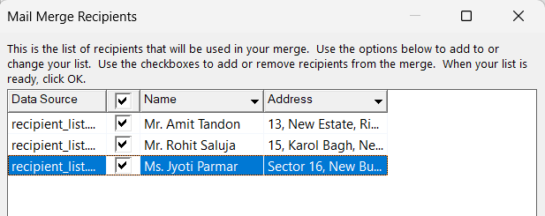
Q2. Create a table in Word as shown below (in manual):
- In the total marks’ column, entries should be calculated using formulas and it is the sum of marks in physics and marks in chemistry.
- Insert a new row at the end of the table and also find grand total using formula.
- Sort the table based on total marks.
- The date and heading should be centre aligned.
- Heading should be in bold and underlined.
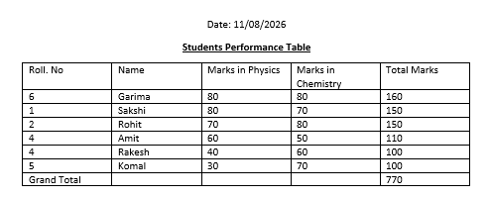
Q3. Using a spreadsheet package, you have studied, construct T Morongo’s pay slip for December 2016 following the instructions below. Insert a custom footer with your name, subject, course, exam/Test & question number. Save it as Salary advice.
- Housing Subsidy 6000.00 per year.
- Car Allowance 100.00 per month.
- Pension 8% onBasic Salary.
- PAYE636.83.
- Medical Aid 70.00.
- U.I.F. 1% on Basic Salary + Housing Subsidy.
- Bond Repayment 630.00.
- Calculate Net Salary.
- Format all figures to two decimal places and insert ₹ currency symbol.
- Insert a custom footer with your name, subject, and question number. Save it as salary advice2
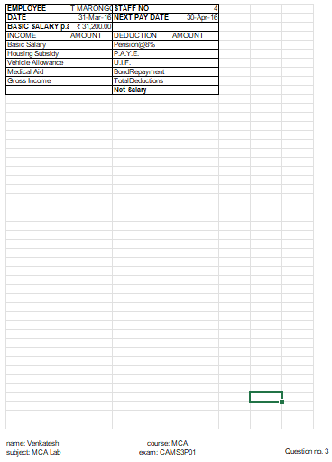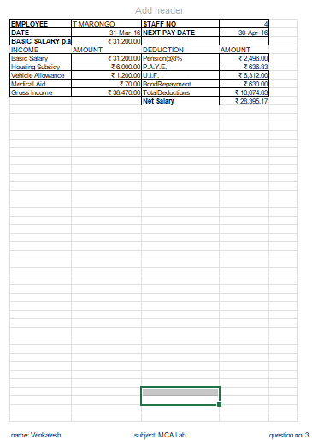
Q4. Use a new workbook & construct a worksheet with the data given & save it as LYONS.
- Markup = Cost price/Litre x 35%
- Selling price = Cost price/Litre + Mark up
- Total income = Litres sold x Selling Price
- Profit =Total income- (Cost price/Litre x Litres sold)
- The MARKUP% (35%) must be inserted in a separate cell under the heading. USE IT as an absolute cell reference in the formula to calculate the mark up per item.
- Calculate the mark up for each item.
- Calculate the selling price for each item.
- Calculate the Total Income for each item.
- Calculate the profit for each item.
- Format the column LITRES SOLD to display the number of litres as integers. The rest of the worksheet must be formatted to display two decimals. g)
- Use statistical functions to calculate the AVERAGE, HIGHEST (MAX.) and LOWEST (MIN) for Selling Price column up to Profit Column.
- Show all formulas you have used in a new sheet. Adjust the column width so that the formulae are displayed in full and the sheets fits into one side of A4 landscape format and save it as formulas.
- Under the worksheet Create a pie chart titled PRODUCT COST PER UNIT for Product & Cost price per Litre columns. Data labels indicating percentages should be displayed.
- Put borders neatly on the on the work sheet & save it as LYONS2.
